|  |
| --- |
| C:\Users\Tsubaki Yukino\Desktop\FlyAwayPlus Project\Capture.JPG |
| **FLY AWAY PLUS** |
| **Installation Guide** |
|  |
| |  |  |  | | --- | --- | --- | | **Fly Away Plus** | | | | **Group Members** | Hoàng Nghĩa Đức | SE02882 | | Dương Thanh Hải | SE02856 | | Nguyễn Minh Hoàng | SE02819 | | Trần Mạnh Hiếu | SE02778 | | Phan Tiến Lực | SE02923 | | Lê Minh Thúy | SE02881 | | **Supervisor** | Mr. Nguyễn Văn Sang | | | **Project code** | FAP | | |
|  |

**- Hanoi, 05/2015 –**

**RECORD OF CHANGE**

*A-Added; M-Modified; D-Deleted

|  |  |  |  |  |
| --- | --- | --- | --- | --- |
| **Effective Date** | **Change Items** | **A*M, D** | **Change Description** | **New Version** |
| 21/08/2015 | User installation | A | Add new | 1.0 |
|  |  |  |  |  |
|  |  |  |  |  |

*Table 1: Record of change*

**SIGNATURE PAGE**

|  |  |  |
| --- | --- | --- |
| **ORIGINATOR** | Lê Minh Thúy |  |
|  | Developer |  |
|  |  |  |
|  |  |  |
| **REVIEWERS** | Hoàng Nghĩa Đức |  |
|  | Developer |  |
|  |  |  |
|  |  |  |
| **APPROVAL** | Nguyễn Văn Sang |  |
|  | Supervisor |  |
|  |  |  |

Table of Contents

**1.** **INTRODUCTION** 5

1.1. Purpose 5

1.2. Environment 5

**2.** **Application Installation** 5

2.1. Set up Environments 5

2.1.1. Set up Neo4j for Windows 5

2.1.2. Installation IIS Manager 14

2.1.3. Installation Web Application 20

# **INTRODUCTION**

## Purpose

This document contains guide-lines step by step to use FAP website, and set up its own database.

## Environment

Following are the software required to start the FAP system:

* Operating System: Windows 7, Windows 8
* Browsers: Firefox 40, Chrome 44 or higher.
* Database: Neo4j 2.2.3 or higher
* .NET Framework 4.5

# **Application Installation**

## Set up Environments

Web: If users want to use FAP system on personal computer, users need to install Chrome 44/Firefox 40 or higher version and Neo4j to create and store database.

## Set up Neo4j for Windows

Download the latest stable version of Neo4j for Windows at: [http://neo4j.org](http://www.neo4j.org/)

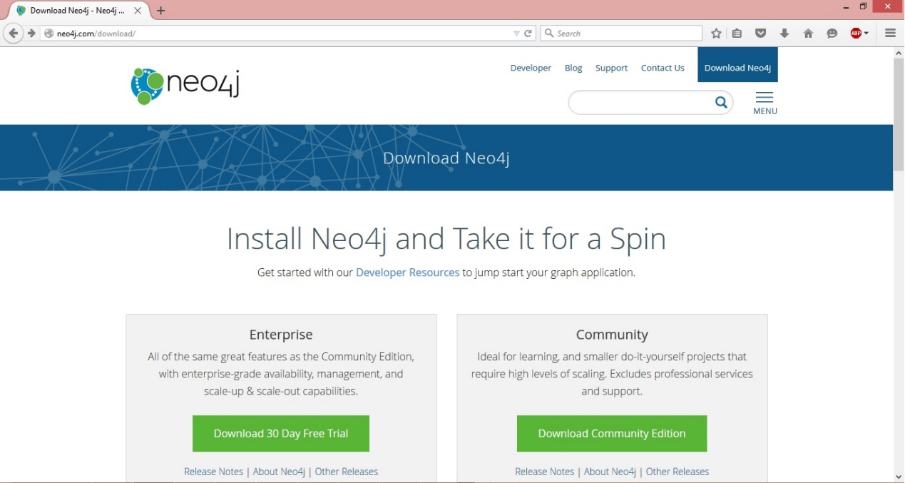

**Step 1:** Run setup file:

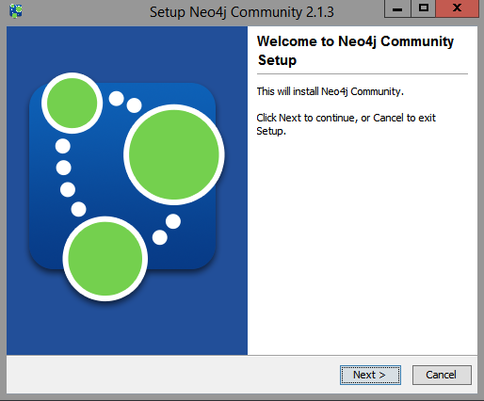

**Step 2:** Click Next to Jump to accept agreement step

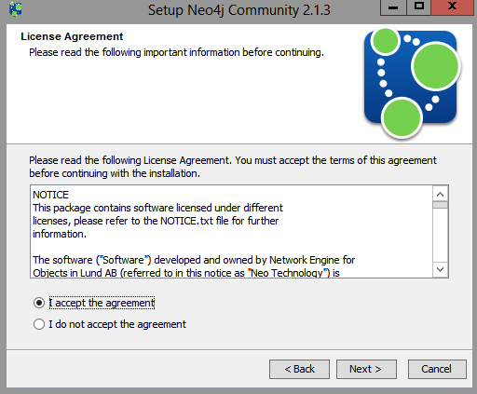

**Step 3:** Then select the folder to install Neo4j:

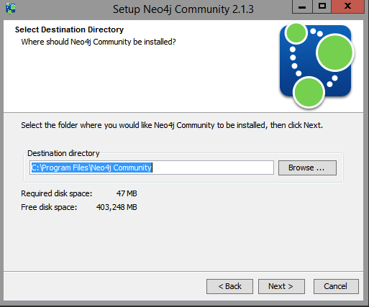

**Step 4:** Select the Start Menu Folder for Neo4j

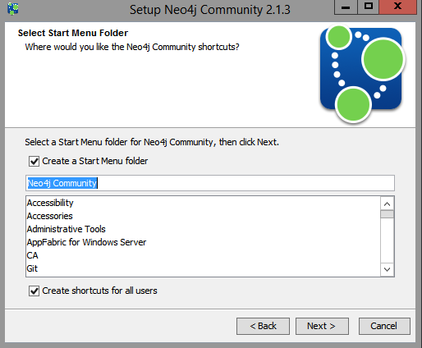

**Step 5:** Wait for the installation step finishes:

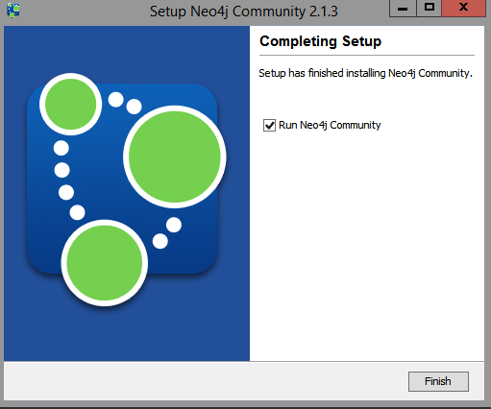

**Step 6:** Start Windows of Neo4j Server – Community Version:

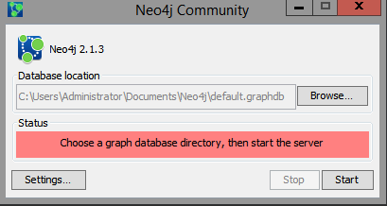

**Step 7:** Before start Neo4j Server, you have to change Setting by clickon Settings button, then click the **Edit…** button for the Database Configuration

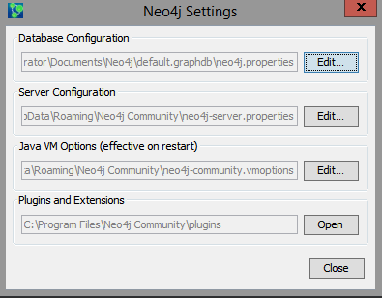

**Step 8:** To enable auto indexing Neo4j technique, in the neo4j.properties file we want to enable **Autoindexing** which is disabled by default.  
Simply remove the number sign (#) at the beginning of the following lines:

node_auto_indexing=truenode_keys_indexable=name,age

Once completed the file should look similar to the following – Close the file to Save and Close the Neo4j Settings

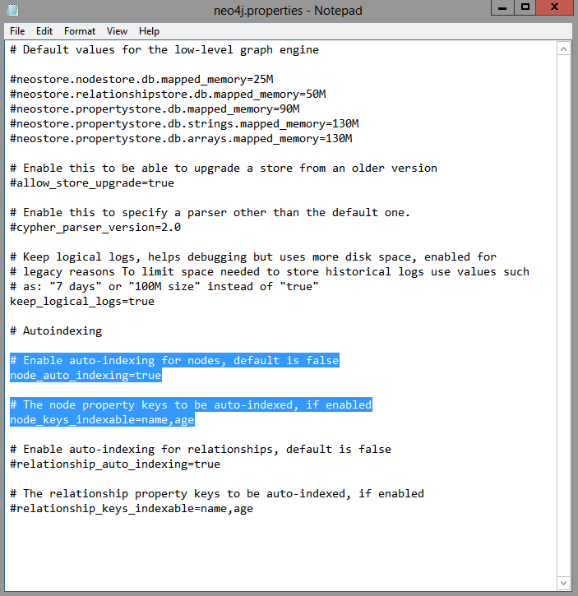

**Step 9:** Start Neo4j:

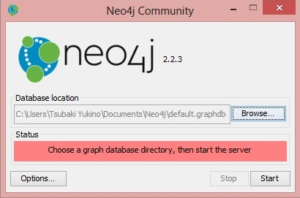

**Step 10:** Click Browse… and select path of the database (Example: ~Sources\Database\GraphDatabase)

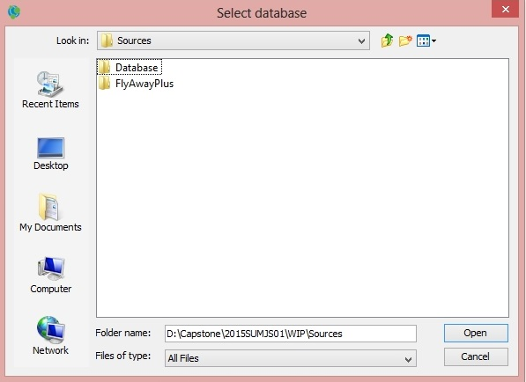

**Step 11:** Click Open and Start and waiting the database is started

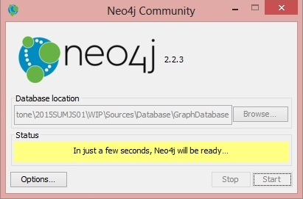

**Step 12:** Neo4j database is ready, click the link <http://locahost:7474/> to browse the database

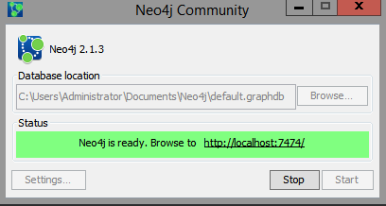

**Step 13:** Browse the database at <http://locahost:7474/>

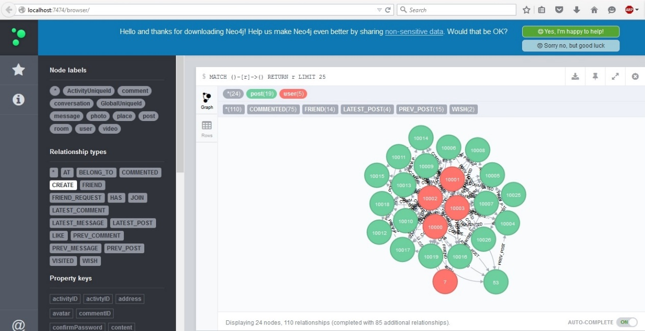

## Installation IIS Manager

## **Step 1:** On the **Start** menu, choose **Control Panel**, and then choose **Programs and Features**

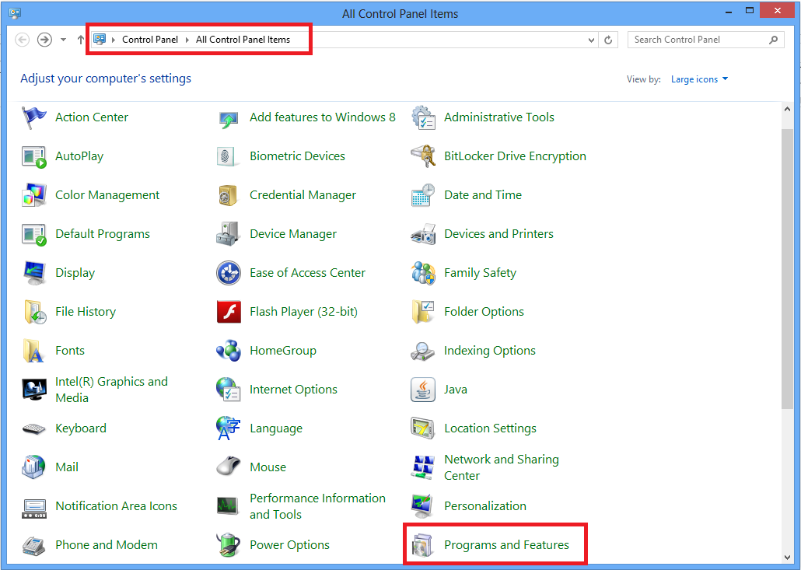

**Step2:** Under **Programs and Features**, choose **Turn Windows features on or off.**

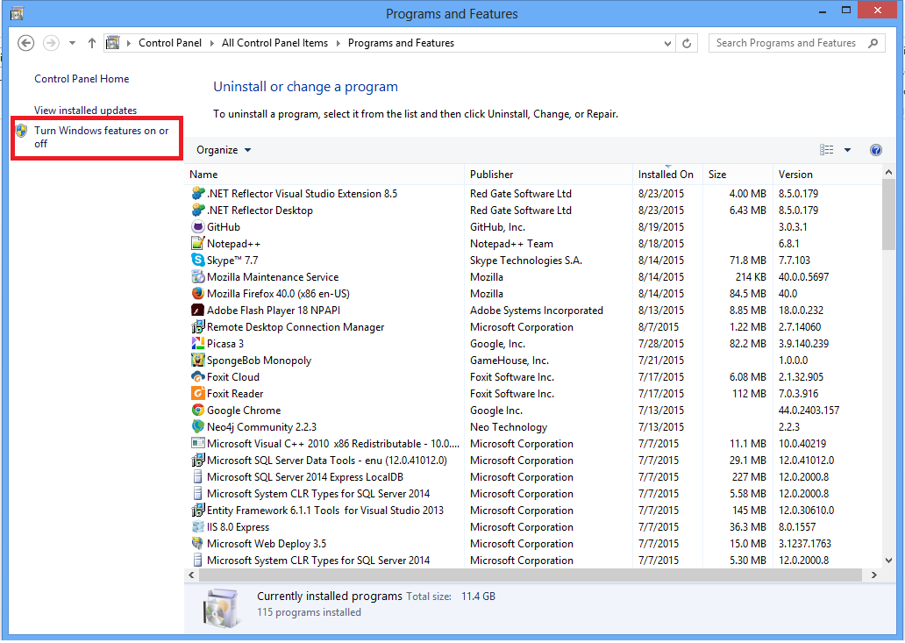

**Step 3:** In the **Windows features** list, expand **Internet Information Services**, and then expand **World Wide Web Services**.

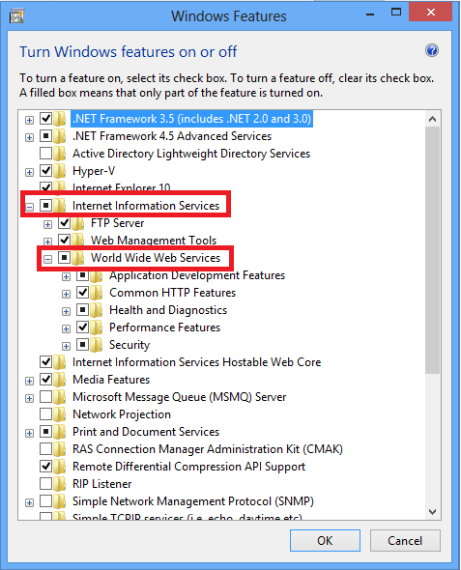

**Step 4:** Expand **Application Development Features**, and select the following features:

* **.NET Extensibility**
* **ASP.NET**
* **ISAPI Extensions**
* **ISAPI Filters**

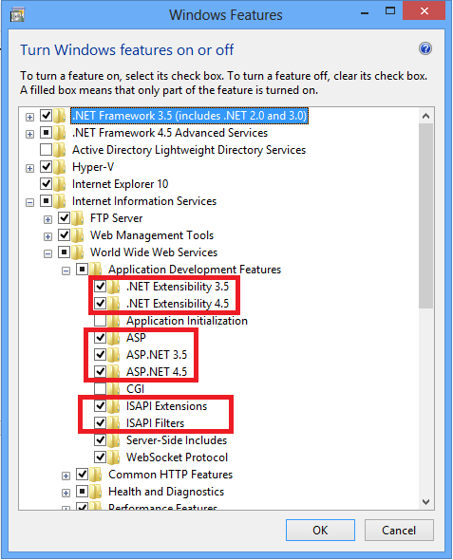

**Step 5:** Expand **Security**, and then select the following features:

* **Request Filtering**
* **Basic Authenticate**
* **Centralized SSL Certificate Support**
* **Windows Authentication**

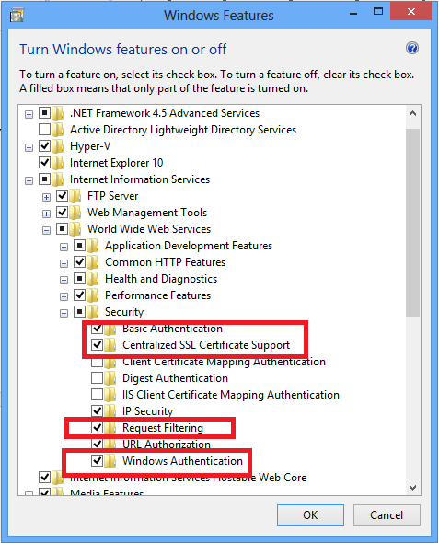

**Step 6:** Expand **Common HTTP Features**, and then select the **All** feature.

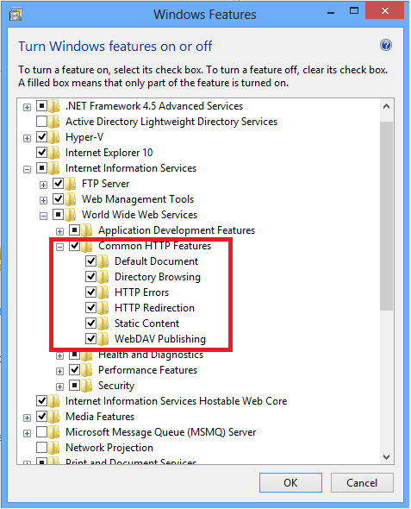

**Step 7:** under **Internet Information Services**, expand **Web Management Tools**, and then select **All**.

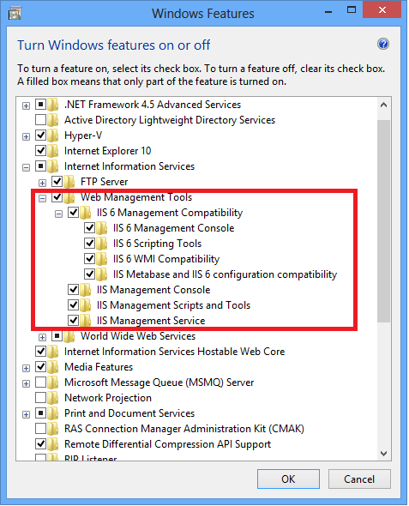

**Step 8:** Choose the **OK** button and then restart computer to complete the installation.

## 

## 2.1.3. Installation Web Application

## **Step 1:** Preparing package **FlyAwayPlus.rar**. Make sure package is available (incorrupt).

**Step 2:** Copy file **FlyAwayPlus.rar** to folder **C:\inetpub\wwwroot** .

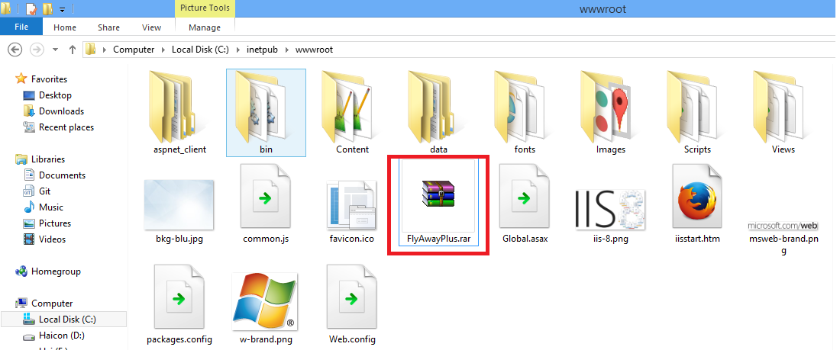

**Step 3:** Extract file FlyAwayPlus.rar, select “Extract here”.

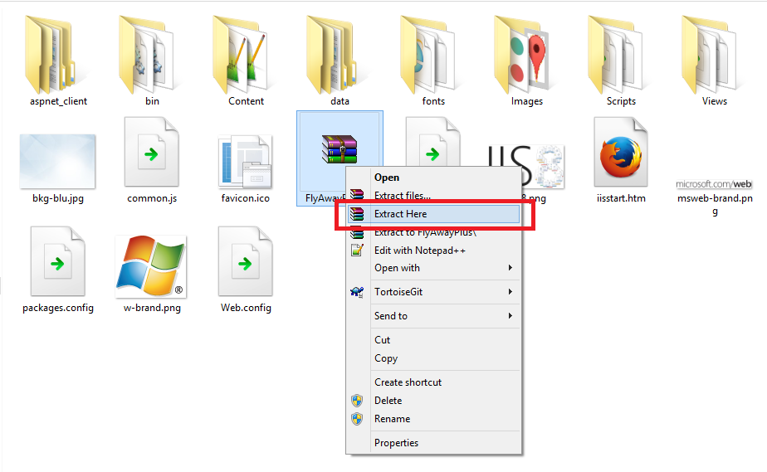

**Step 4:** Open Browser (Chrome or Firefox) and go to link

<http://localhost/Home/Index/>

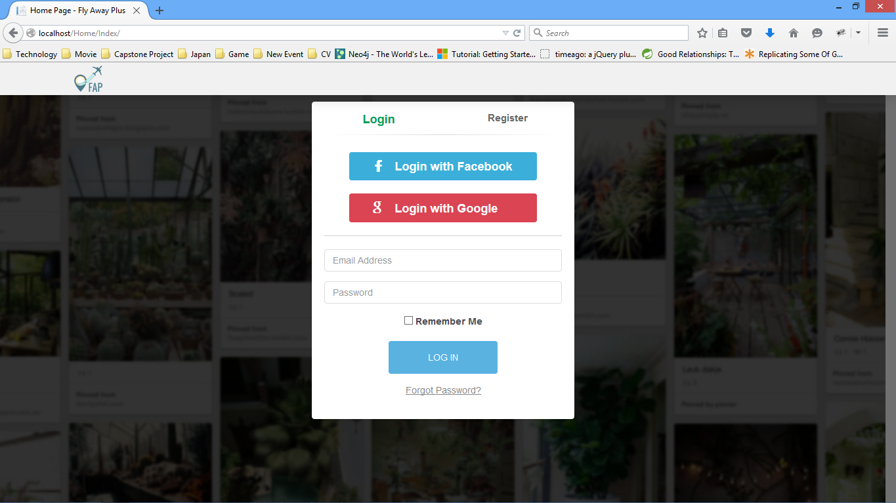

<http://localhost/Admin/Index/>

